|  |  |  |
| --- | --- | --- |
| une tour | une porte | une fenêtre |
| le ciel | la table | un torrent |
| un ballon | la mer |  |

C:\Documents and Settings\Sandra Trachsel\Local Settings\Temporary Internet Files\Content.IE5\SX459902\MC900324166[1].wmf

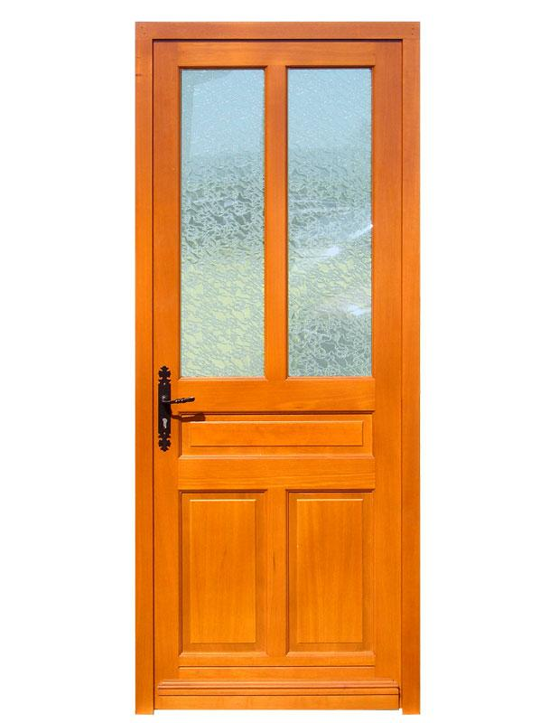

C:\Documents and Settings\Sandra Trachsel\Local Settings\Temporary Internet Files\Content.IE5\1MIPUWK2\MC900389388[1].wmf

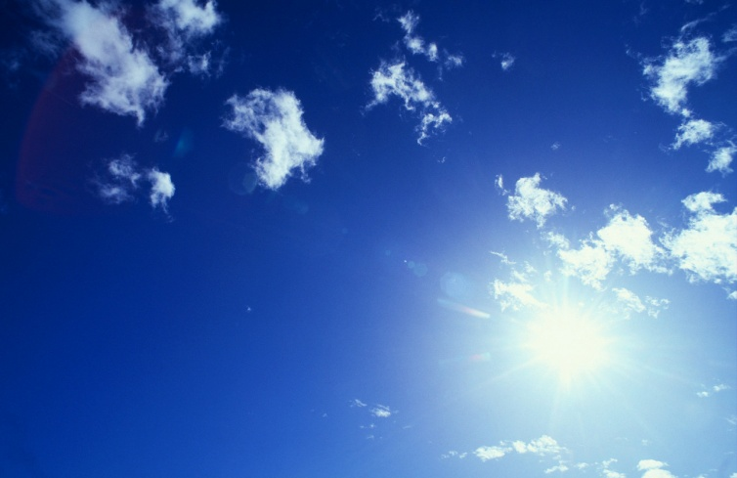

C:\Documents and Settings\Sandra Trachsel\Local Settings\Temporary Internet Files\Content.IE5\1MIPUWK2\MC900013394[1].wmf

C:\Documents and Settings\Sandra Trachsel\Local Settings\Temporary Internet Files\Content.IE5\VCZZ12DR\MC900282938[1].wmf



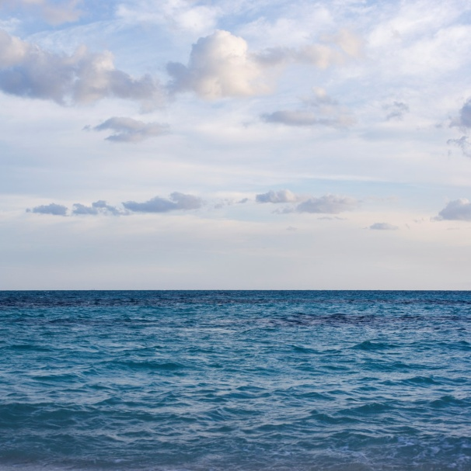

|  |  |  |  |
| --- | --- | --- | --- |
| une | une | une | le |
| la | un | un | la |

C:\Documents and Settings\Sandra Trachsel\Local Settings\Temporary Internet Files\Content.IE5\SX459902\MC900324166[1].wmf

tour



porte

C:\Documents and Settings\Sandra Trachsel\Local Settings\Temporary Internet Files\Content.IE5\1MIPUWK2\MC900389388[1].wmf

fenêtre



ciel

C:\Documents and Settings\Sandra Trachsel\Local Settings\Temporary Internet Files\Content.IE5\1MIPUWK2\MC900013394[1].wmf

table

C:\Documents and Settings\Sandra Trachsel\Local Settings\Temporary Internet Files\Content.IE5\VCZZ12DR\MC900282938[1].wmf

torrent



ballon



mer